Peter the Great St. Petersburg Polytechnic University

Institute of Computer Science and Cybersecurity

Graduate School of Computer Technologies and Information Systems

**Lecture: Nios II Custom Components and Instructions**

Subject: Automation of discrete device design (in English)

Completed by student of group 5130901/10101 Nepomnyaschiy M.T.

(signature)

Lecturer Antonov A.P.

(signature)

Saint Petersburg

2024

**Table of contents**

Introduction 4

2. Custom Components 4

2.1. Custom Components 4

2.2. Example Signal Mapping 5

2.3. Component Editor 5

2.3.1. Component Editor (Component Type Tab) 6

2.3.2. Component Editor (Files Tab) 6

2.3.3. Component Editor (Signals Tab) 7

2.3.4. Component Editor (HDL Parameters) 7

2.3.5. Component Editor (Interfaces Tab) 8

2.4. “hw.tci” File 9

2.5. Custom Component Integration Into Qsys System 9

2.6. Edit Component Parameters 10

3. Custom Instructions 11

3.1. Custom Instructions 11

3.2. Create Custom Instructions in Qsys 12

3.3. Add Custom Instruction to System 13

3.4. Language Software Interface 14

3.5. Nios II Software Instruction User Guide 15

4. Custom Instruction vs. Custom Component 16

Conclusion 17

**List of illustrations**

Figure 1 – Nios II Embedded Design Suite 4

Figure 2 – Example Signal Mapping 5

Figure 3 – Component Editor 5

Figure 4 – Component Type Tab 6

Figure 5 – Files Tab 6

Figure 6 – Signals Tab 7

Figure 7 – HDL Parameters 7

Figure 8 – Interfaces Tab 8

Figure 9 9

Figure 10 – Custom Component Integration Into Qsys System 9

Figure 11 – Edit Component Parameters 10

Figure 12 – Custom Instructions 11

Figure 13 – Create Custom Instructions 12

Figure 14 – Add Custom Instruction to System 13

Figure 15 – Language Software Interface 14

Figure 16 - Nios II Software Instruction User Guide 15

Figure 17 – Custom Instruction vs. Custom Component 16

# Introduction

The presentation revolves around optimizing Nios II processor systems through custom components and instructions. It explores how these customizations enhance system performance, comparing the benefits of custom components versus custom instructions. Understanding these customization options is crucial for maximizing efficiency in embedded systems.

# 2. Custom Components

You can make custom components for Nios II processor systems. This is useful for systems where certain tasks are done a lot. Making these tasks into hardware components makes them faster than doing them with software. Also, it lets the processor do other things while the custom component works. Qsys has a tool called the Component Editor for making these custom components.

## Custom Components

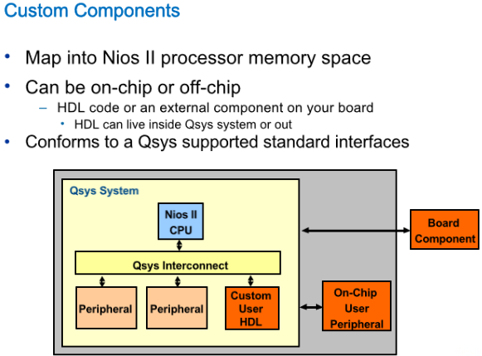

Figure 1 – Nios II Embedded Design Suite

To connect custom components to your Nios II system and Qsys Interconnect, you have a few options.

1. Custom user logic inside Qsys: You can integrate custom components directly into your Qsys system module.
2. Peripheral outside Qsys module on the same FPGA: Alternatively, the custom component can be outside the Qsys module but still on the same FPGA.
3. Off-chip connection: You can also connect custom components off-chip by routing signals to the FPGA pins and linking them to components on another board.

## Example Signal Mapping

Figure 2 – Example Signal Mapping

Altera's tool flow makes it easy to connect custom components to the system interconnect.

Using the Qsys component editor, you can easily map the ports of your component to equivalent signal types in the System Interconnect. For example, if your component is a Verilog module named "my peripheral" and it's a MM Slave component, you can map its clk to the clk signal and wr_data to writedata, and so on, following the Avalon MM Standard Interface signal types in Qsys.

For signals that don't fit into the standard interface, like the signal_out output signal mentioned here, you can map them to the export signal of the conduit interface. This simplifies the integration process even for non-standard signals.

## Component Editor

Figure 3 – Component Editor

The tool you use to map signals in your component to their corresponding Avalon interface and signal types is called the "Component Editor." You can access it from within Qsys, either directly from the IP Catalog or through the File menu. The Component Editor has several tabs for different functions or settings.

### Component Editor (Component Type Tab)

Figure 4 – Component Type Tab

The Component Type tab is where you input basic information about the component, such as its name, description, and icon. You can also include links to documentation here. This information will be visible in the component's parameter editor. The Display Name determines how the component will appear in the Component Library, while the Group decides the folder it will be in. You can choose an existing folder or create a new one. By default, new components are placed in a folder called "Custom Logic."

### Component Editor (Files Tab)

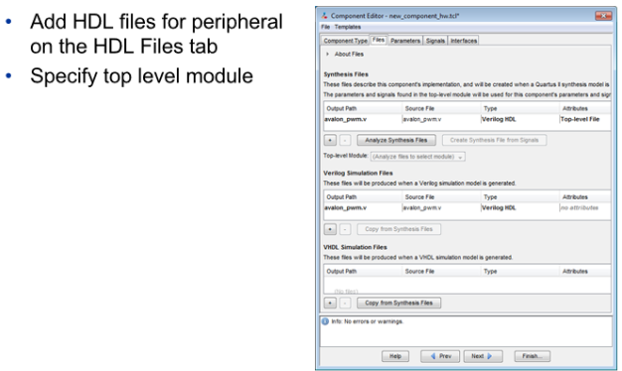

Figure 5 – Files Tab

In the HDL Files tab of the component editor, you can add the HDL files that comprise your peripheral. You can also specify the top level of the component hierarchy if needed. Additionally, you can choose whether each file is used for simulation and/or synthesis. When you add HDL files, the component editor runs analysis and elaboration on them to catch errors and understand the structure of the code, including input/output signals and parameters associated with the component.

### Component Editor (Signals Tab)

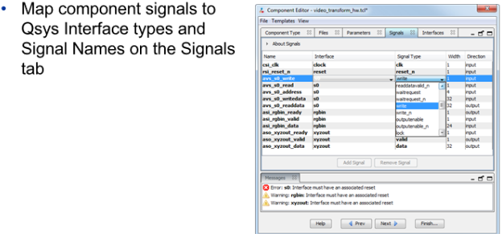

Figure 6 – Signals Tab

In the Signals Tab of the Component Editor, you can map the signals in your component to the Avalon Standard Interface signal names. Additionally, you can create interfaces if needed. If you've named signals in your component's HDL file appropriately, the component editor will automatically recognize and map the signals, saving you from manually mapping them.

### Component Editor (HDL Parameters)

Figure 7 – HDL Parameters

In the Signals Tab of the Component Editor, if your component's HDL code includes parameters or generics, they will appear here. This allows you to override their default settings for each instance in your system. Additionally, you can preview the graphical user interface (GUI) that appears when your IP is instantiated, along with the parameters that can be adjusted. This gives you control over customizing your component's behavior.

### Component Editor (Interfaces Tab)

Figure 8 – Interfaces Tab

In the Interfaces Tab of the Component Editor, you can define parameters for your component's interfaces. This includes timing parameters, creating new interfaces if necessary, assigning clocks and resets, and removing unused interfaces identified in the Signals Tab. By navigating through all the animations, you'll be guided through the entire peripheral UI, enabling you to configure and customize your component comprehensively.

## “hw.tci” File

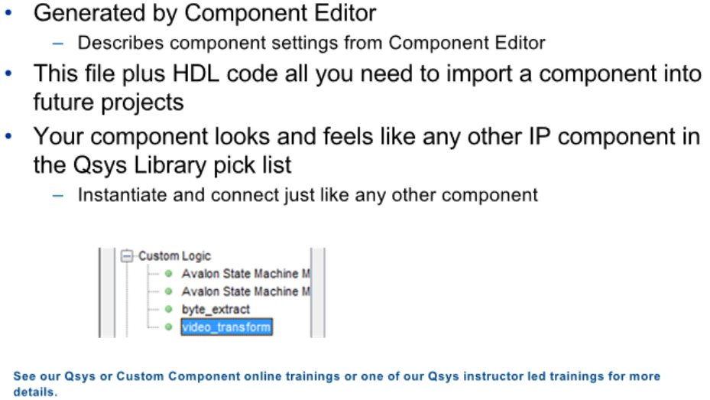

Figure 9

The Component Editor generates an output file known as the hardware Tcl file. This file captures all the settings configured in the Component Editor GUI. Importing your component into another Qsys project is simple: ensure that Qsys can locate the hardware Tcl file, as well as the associated HDL and/or SDC files for your component. This streamlined process facilitates easy integration of custom components into different Qsys projects.

## Custom Component Integration Into Qsys System

Figure 10 – Custom Component Integration Into Qsys System

In this example system, a custom component is integrated, featuring both master and slave ports that connect to the interconnect. This means the component can both initiate transactions (master) and respond to requests from other components (slave). This versatility allows the custom component to interact effectively within the system, enhancing its functionality and capabilities.

## Edit Component Parameters

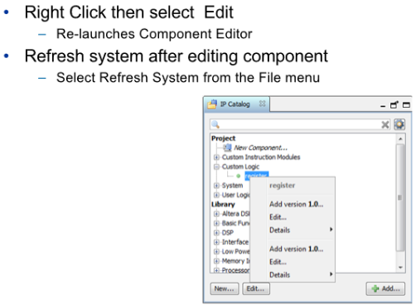

Figure 11 – Edit Component Parameters

If you need to modify the settings of your peripheral in the Component Editor, you can do so by right-clicking on the component in the library and selecting Edit. This action relaunches the Component Editor, enabling you to make changes and regenerate the hardware Tcl file. This "in-place" editing feature eliminates the need to remove and re-instantiate components for changes to take effect. However, remember to refresh the system after making changes so that Qsys re-reads all the_hw.tcl files in your project to ensure the updates are applied correctly.

# Custom Instructions

With the Nios II processor, you can make software run faster by adding custom instructions. These instructions simplify complex tasks, like digital signal processing or packet processing, turning multiple steps into just one hardware-based step. This makes your programs more efficient, especially for tasks that need to be done quickly.

## Custom Instructions

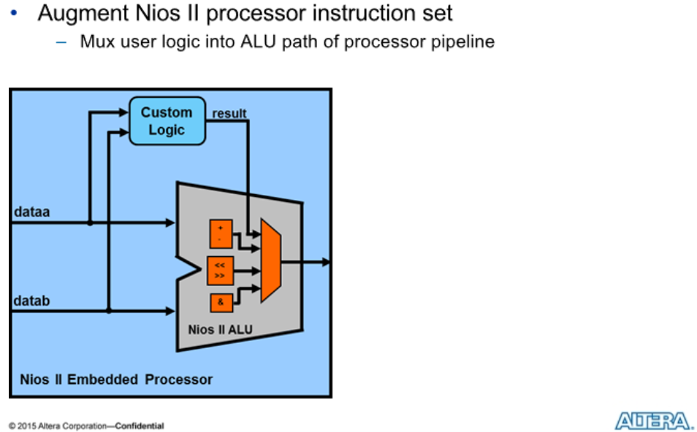

Figure 12 – Custom Instructions

Custom instructions in the Nios II processor are like personalized tools that sit alongside the main processing unit. They're designed to handle specific tasks efficiently. These instructions can be simple, just needing inputs and outputs, or more complex, requiring extra signals. Each processor can have up to 256 of these customized instructions. They can also communicate with the processor's memory using additional signals. If needed, they can even talk to other parts of the system through a special interface. This customization gives developers the flexibility to fine-tune the processor for their specific needs, making their applications run smoother.

## Create Custom Instructions in Qsys

Figure 13 – Create Custom Instructions

To import a custom instruction, you utilize the component editor similar to creating a custom component. Within the editor, select "nios_custom_instruction" as the interface type for your signals. Custom instructions can be developed using Verilog, VHDL, or EDIF formats. Once created, these instructions will appear in the component pick list under the Custom Instruction Modules folder. From there, you can effortlessly add them to your system and establish connections to the Nios II Processor.

## Add Custom Instruction to System

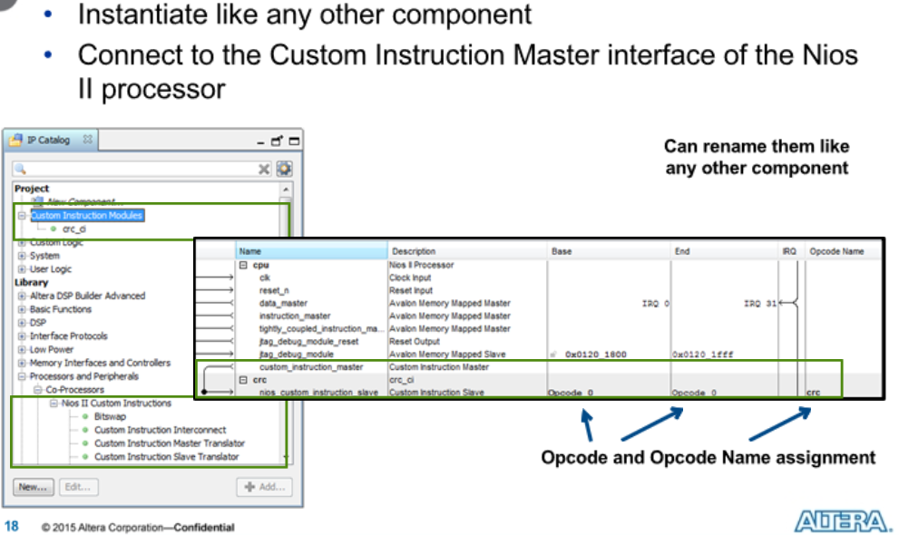

Figure 14 – Add Custom Instruction to System

Once you've added the custom instruction from the IP Catalog, you can rename its instance just like any other component. Once integrated into the Qsys system, you can then connect it to the Custom Instruction Master Interface of the Nios II Processor. This interface allows the processor to communicate with and utilize the custom instruction effectively within the system.

## Language Software Interface

Figure 15 – Language Software Interface

Custom instructions offer a straightforward software interface. The macro to invoke your custom instruction is automatically defined in the system.h file of your BSP project, prefixed with ALT_CI. For instance, consider the example of performing a bit swap, a task that's challenging in software but simple in hardware. By employing the bit swap custom instruction, you can achieve around a 70x performance boost. In the provided code snippet, the macro is used to pass the integer "a" to the custom instruction, and the result is stored in "a_swap." This streamlined interface enhances performance significantly for tasks that benefit from hardware acceleration.

## Nios II Software Instruction User Guide

Figure 16 - Nios II Software Instruction User Guide

For further details on custom instructions, refer to the Nios II Custom Instruction User Guide accessible at Altera.com. This resource provides comprehensive information and guidance on leveraging custom instructions to enhance the performance and functionality of Nios II processors.

# Custom Instruction vs. Custom Component

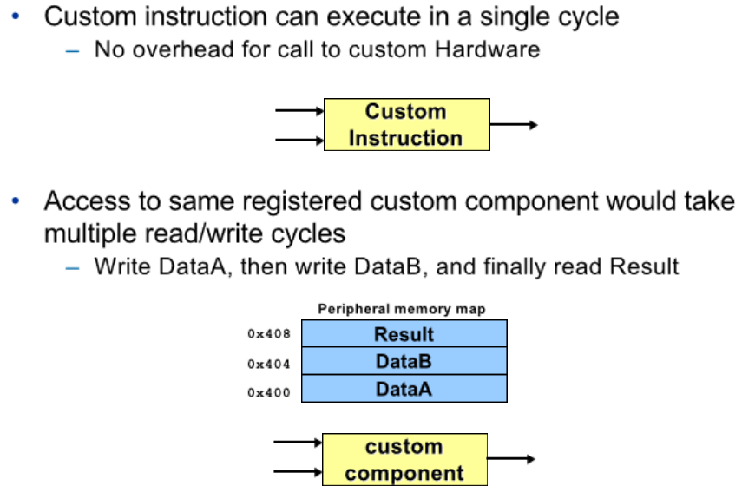

Figure 17 – Custom Instruction vs. Custom Component

Deciding between custom components and custom instructions hinges on your specific application. Both offer significant performance enhancements over software-only operations.

Custom instructions excel in tasks that require minimal setup and can be executed in a single cycle without going through the System Interconnect. They are ideal for operations with up to two inputs and one output, such as Floating Point Multiply, where you can achieve up to a 30X performance improvement over optimized software.

For more complex algorithms like CRC calculations, custom components may be preferable. They offer better performance by incorporating additional capabilities like DMA to accelerate operations. Custom components are particularly beneficial for tasks requiring extensive computation or data manipulation beyond what custom instructions can provide.

# Conclusion

Custom components and instructions offer powerful tools for enhancing the performance of Nios II processor systems. By tailoring the processor core to specific application needs, developers can achieve significant performance improvements. Whether utilizing custom components for complex algorithms or leveraging custom instructions for streamlined operations, the flexibility provided by these customization options empowers designers to optimize system efficiency. As embedded systems continue to evolve, understanding and harnessing the capabilities of custom components and instructions will remain essential for achieving optimal performance and functionality.